9 SCIENCE 2014

CHEMISTRY TEST ONE: THE ATOM

Name: ____________________ Teacher: ___________________ Mark: /50

Percentage: %

SECTION A: MULTIPLE CHOICE (5 marks)

Select the most correct answer for each question below.

1. The third electron shell of an atom can only hold:

(a) 18 electrons.
(b) 2 electrons.
(c) 8 electrons.
(d) 4 electrons.

2. To work out the number of neutrons in an atom:

(a) Take the atomic number from the mass number.
(b) Take the mass number from the atomic number.
(c) Add the mass number to the atomic number.
(d) Add the number of electrons to the number of protons.

3. How many of the known elements are found naturally on Earth?

(a) 87
(b) 94
(c) 79
(d) 91

4. The definition that best describes the word ‘element’ is:

(a) The fundamental building block of all materials.
(b) A substance made up of only one type of atom.
(c) A substance made up of two or more types of atoms.
(d) A metal that has many atoms.

5. H2O (water) is an example of a/an:

(a) Element.
(b) Crystal lattice.
(c) Compound.
(d) Mixture.

SECTION B: SHORT ANSWER (45 marks)

1. State the difference between an element and a compound. (2 marks)

_______________________________________________________________________________________

_______________________________________________________________________________________

_______________________________________________________________________________________

2. Label the diagram of the atom below. (2 marks)
Beryllium

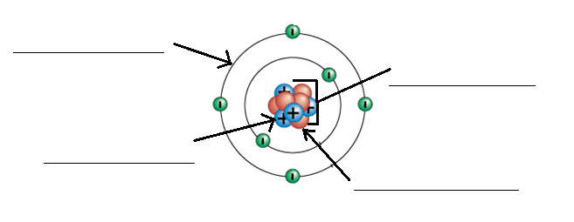
3. Follow the instructions below (draw neatly and in pencil). (4 marks)

a. In the box to the right draw a compound with three atoms.

b. In the box to the right draw a compound with two atoms.

c. In the box to the right draw an element with two atoms.

d. In the box to the right draw an example of a molecule.

4. Fill in the missing element names and symbols below. (10 marks)

ELEMENT | SYMBOL
Hydrogen
Helium
 | Li
 | Be
 | B
Carbon
 | N
 | O
Fluorine
 | Ne
Sodium
Magnesium
 | Al
Silicon
Phosphorus
 | S
 | Cl
 | Ar
Potassium
 | Ca

5. Label the diagram below using the words given. (2 marks)

Atomic number, element name, element symbol, mass number

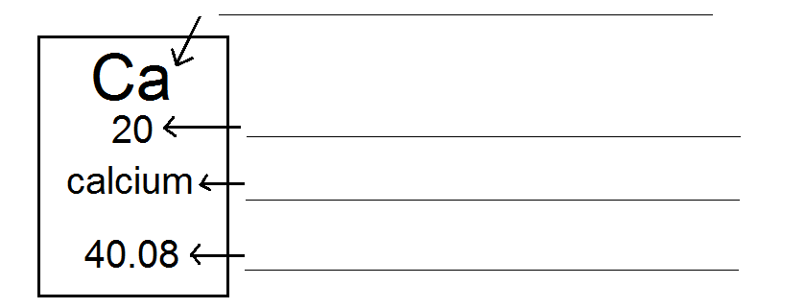

6. Write definitions for the terms below. (4 marks)

Periodic table: _________________________________________________________________________

_____________________________________________________________________________________

_____________________________________________________________________________________

_____________________________________________________________________________________

Atom: _______________________________________________________________________________

_____________________________________________________________________________________

_____________________________________________________________________________________

_____________________________________________________________________________________

7. Fill in the missing words. (2 marks)

The nucleus is made up of _________________ and _____________________.

_____________________ have a positive charge while ____________________ have a negative charge.

8. Identify which atoms are isotopes of the same element. (1 mark)

___________________

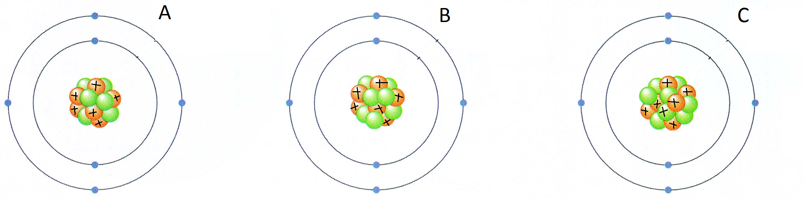

9. Write the term next to its matching definition below. (5 marks)

Electron configuration, electron shell, atomic number, mass number, isotope

a) The number of protons and neutrons in the nucleus of an atom.

_________________________________________________

b) Atoms that have the same number of protons but a different number of neutrons in their nucleus.

_________________________________________________

c) The number of protons in the nucleus of an atom.

_________________________________________________

d) The number of electrons in each electron shell of an atom.

_________________________________________________

e) The layer that surrounds the nucleus and holds electrons.

_________________________________________________

10. Complete the electron configurations below (neatly in pencil). (6 marks)

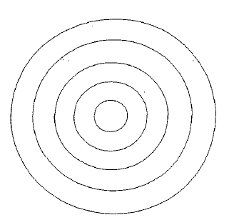
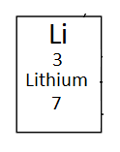
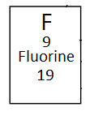

11. State the difference between a mixture and a compound. (2 marks)

_______________________________________________________________________________________

_______________________________________________________________________________________

_______________________________________________________________________________________

_______________________________________________________________________________________

12. Determine the following for the element potassium. (3 marks)

Number of protons: _________
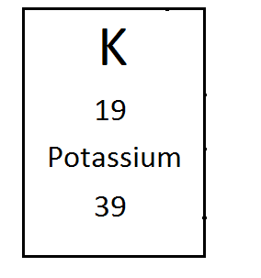
Number of electrons: _________

Number of neutrons: _________

Atomic number: _________

Mass number: _________

Element symbol: _________

13. Propose why atomic symbols are the same all over the world. (2 marks)

_______________________________________________________________________________________

_______________________________________________________________________________________

_______________________________________________________________________________________

_______________________________________________________________________________________

